MOBILE DATA USAGE AND INTERNET COST IN NIGERIA

Authors: Akinbami Abosede Sera and Muhammed Isiwat Opeyemi

ABSTRACT
Mobile data cost remains the major factor that influences the accessibility and usage patterns of the internet. This study on Mobile Data Usage and Internet Cost in Nigeria aims to examine how users behave and the preferences within the Nigerian mobile data market. The research design applied in this study was quantitative descriptive research design and Google Form questionnaire was adopted for the data collection. The findings of the study showed that 122 valid answers gathered via online survey and were found usable. The findings shows that MTN is the most popular mobile network to access the internet in Nigeria with Airtel, Glo, and 9mobile coming after it. Also, the findings of the study showed that the most frequent data use purposes were social media (WhatsApp, Instagram, and Facebook), online learning or research, business, and entertainment. The study also shows that the average spending of the MTN users was the highest (₦7,105.77). The results of the study revealed that Glo has the highest satisfaction rate of (3.8), while 9mobile, MTN and Airtel has the rate of (3.4), (3.1), and (3.0) respectively. The findings showed that there was a positive correlation between monthly data budgets and actual data usage. Additionally, the study showed that majority faced the challenges of poor network speed (42 responses), finished data too fast (38), and high cost (27). The study concluded that the affordability of data, broader coverage, and improved service quality are the most effective ways to increase user satisfaction and encourage more individuals to engage in the rapidly expanding digital economy in Nigeria.

Contents
ABSTRACT 2
Introduction 4
Research Objectives 4
METHODOLOGY 5
Research Design 5
Population of the Study 5
Sampling Technique 5
Method of Data Collection 5
Method of Data Analysis 5
Ethical Considerations 6
RESULTS AND ANALYSIS 6
Demographic Information of Respondents 6
Gender Distribution 6
Location Distribution 6
Occupation Distribution 7
Devices Used for Internet Access 7
Data Affordability Opinion of Nigerians 8
Most Used Network for Internet Access in Nigeria 8
Mobile Data Usage Patterns in Nigeria 9
Average Monthly Data Spending in Nigeria 9
Average Satisfaction Rating with Mobile Data Services 10
Relationship Between Monthly Data Budget and Data Usage 10
Challenges in Mobile Data Usage 11
Summary of Findings 11
Conclusion 12
References 13

Introduction
Over the past years, the use of mobile internet has been a key aspect of everyday life in Nigeria, which has affected communication, business processes, education, and entertainment (GSMA, 2024). As the digital services and mobile technology are rapidly expanding, Nigerians depend so much on mobile data to use the internet. However, the prices of data, network coverage and quality of services still define the way people use the internet in various parts of the country (GSMA, 2024; GSMA, 2025).
Mobile data cost remains the major factor that influences the accessibility and usage patterns of the internet. Although there are users who can afford large data plans for streaming and online work, there are users who do not use the internet because of its high cost, or because the service is not reliable (GSMA, 2025). With the increased internet usage, it is important to learn how Nigerians consume mobile data, which type of network they prefer, and how price affects their online behaviours, as it is crucial to the policy makers, the telecommunication companies and even the consumers themselves.
The proposed study on Mobile Data Usage and Internet Cost in Nigeria aims to examine how users behave and the preferences within the Nigerian mobile data market. The research offers valuable insights on the influence of cost and service quality on the digital activities in the country by analysing the data usage trends, network options, budgets, customer satisfaction levels, and the correlation between budget and data consumption.

Research Objectives
The specific objectives of this study are to:
- Determine the most used mobile network for internet access in Nigeria.
- Examine mobile data usage patterns among Nigerians.
- Analyse the average monthly spending on mobile data in Nigeria.
- Assess the level of user satisfaction with mobile data services in Nigeria.
- Investigate the relationship between monthly data budget and actual data usage among Nigerians.
- Identify major Challenges in Mobile Data Usage

METHODOLOGY

Research Design
The research design applied in this study was quantitative descriptive research design to gain knowledge of patterns in mobile data usage and how internet cost influences user behaviour in Nigeria. The design was selected as it can be used to collect and statistically analyse data systematically to describe existing trends, preferences and relationships between variables like data use, cost and satisfaction.

Population of the Study
The sample size of the study comprises Nigerian mobile data users accessing the internet via different network providers. One hundred and twenty-two valid responses were received and analysed. These observations depict people across various regions of Nigeria with diverse internet experience and expenditure patterns.

Sampling Technique
The sampling method adopted was random whereby all the participants had equal opportunity of being chosen. This approach reduces bias and gives a balanced picture of the Nigerian internet users and more generalised results can be drawn about the Internet cost and mobile data usage.

Method of Data Collection
The data were gathered using a Google Form questionnaire that was created and distributed over the internet. The questionnaire contained close-ended questions on the preferred network providers of the respondents, data usage, monthly expenditure, satisfaction with the mobile services and the connexion between the data budget and consumption. The online method was selected because it is convenient and has a vast target market among the mobile internet users.

Method of Data Analysis
Data obtained were cleaned and analysed with various tools to facilitate accuracy and generation of insight:
- Data cleaning operations such as renaming variables, converting data types, giving midpoints to numeric ranges and eliminating inconsistencies were carried out in Microsoft Excel
- SQL was used for querying.
• Data visualisation and presentation of findings using charts were done using power BI.
This set of tools made it possible to analyse the pattern of mobile data usage, spending behaviour, and satisfaction levels in a comprehensive and reliable way.

Ethical Considerations
Ethics were observed during the research process. The study was a voluntary process and the respondents were made aware of the study purpose prior to filling in the questionnaire. No personal or identifiable data were gathered, so there was anonymity and confidentiality of the respondents. Data were not utilised in any other way other than academic and analytical use.

RESULTS AND ANALYSIS

Demographic Information of Respondents

Gender Distribution
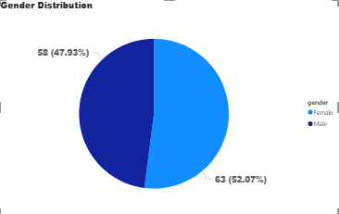
Figure 1: Gender Distribution of Respondents
Out of the 122 respondents, 63 (52.07) were females and 58 (47.93) were males. This presents a relatively equal gender distribution which implies that both male and female customers actively access mobile data services in Nigeria.

Location Distribution
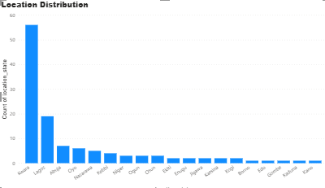
Figure 2: Location Distribution of Respondents
Respondents were sampled in various states within Nigeria like Kwara, Lagos, Abuja, Oyo, Nasarawa, Kebbi, Niger, Ogun, Osun, Ekiti, Enugu, Jigawa, Katsina, Kogi, Borno, Edo, Gombe, Kaduna and Kano and most respondents were found in Kwara and Lagos, which are urban and semi-urban regions with generally higher internet penetration.

Occupation Distribution
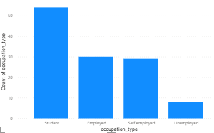
Figure 3: Occupation Distribution of Respondents
The occupational data showed that the largest number of respondents was composed of students, then employed and self-employed people with a smaller proportion made up of unemployed. This indicates that the use of mobile internet is very high among the youth and working age groups particularly students who use mobile data to study and communicate.

Devices Used for Internet Access
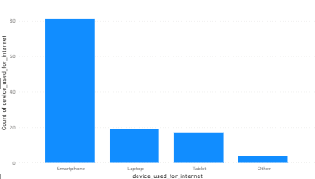
Figure 4: Distribution of Device use for Internet Access
Most of the respondents accessed the internet through smartphones with a minority using laptops, tablets and other devices. This implies that mobile phones are still the main form of internet access in Nigeria, in line with the popularity of mobile broadband services

Data Affordability Opinion of Nigerians
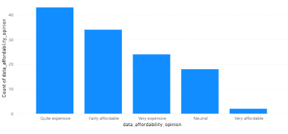
Figure 5: Distribution of Data Affordability in Nigeria
The majority of the respondents described data as expensive and affordable. Very few considered it as very affordable. This indicates that internet price is a significant issue to most Nigerians and this could affect their browsing patterns and level of data usage.

Most Used Network for Internet Access in Nigeria
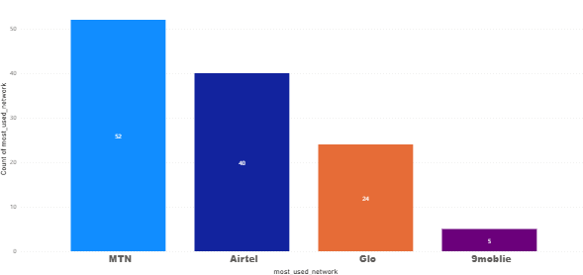
Figure 6: Bar chart showing the most used mobile network in Nigeria.
Figure 6 illustrates the most utilised mobile network in Nigeria. The analysis shows that the most used network to access internet is MTN with 52 users and Airtel (40) and Glo (24) and 9mobile (6). This observation indicates that the Nigerian mobile internet market is dominated by MTN, which could be attributed to its wide coverage and relatively high network speed.

Mobile Data Usage Patterns in Nigeria
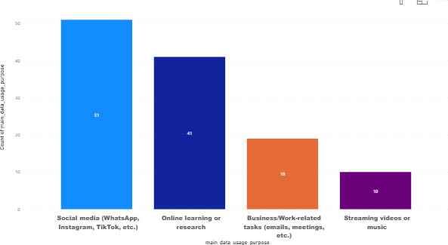
Figure 7: Bar chart showing main purposes of mobile data usage.
Figure 7 illustrates the main purposes for which respondents use mobile data. The majority (51 respondents) reported using mobile data for social media activities, including WhatsApp, Instagram, and Facebook. This was followed by online learning or research, cited by 41 respondents; business or work-related tasks, reported by 19 respondents; and streaming videos or music, indicated by 10 respondents. These results show that mobile data in Nigeria is primarily used for social interaction and communication, while educational and professional purposes also account for a significant portion of usage.
Figure 7 presents the primary reasons when respondents use mobile data. Most (51 respondents) respondents revealed that they used mobile data to engage in social media, which included WhatsApp, Instagram, and Facebook. This was then followed by online learning or research (41 respondents), business or work-related things (19 respondents) and streaming videos or music (10 respondents). These findings demonstrate that mobile information in Nigeria is consumed mainly on social interaction and communication, with educational and business purposes also taking a good portion of the usage.

Average Monthly Data Spending in Nigeria
Table 1: Average Monthly Data spending in Nigeria
Network Provider | Average Monthly Spending (₦)
MTN | 7,105.77
Glo | 5,812.50
Airtel | 4,837.50
9mobile | 5,200.00
Total | 6020.66

Table 1 indicates the average monthly expenditure of data in Nigeria. The outcome reveals that the monthly average amounts spent on mobile data differ among the respondents depending on the network provider. The highest spending is incurred by the MTN users who spend an average of 7,105.77 per month and Glo with an average of 5812.50, 9mobile with 5200.00 and Airtel with 4837.50. It means that the amount of funds spent by the subscribers of the MTN network on mobile data is higher than the amount spent by the users of the other networks. The discrepancies in expenditure can be due to the differences in the price of data plans, network coverage, or preference of the users, whereby the MTN might have plans that are higher priced or high data plans that the respondents are willing to pay.

Average Satisfaction Rating with Mobile Data Services
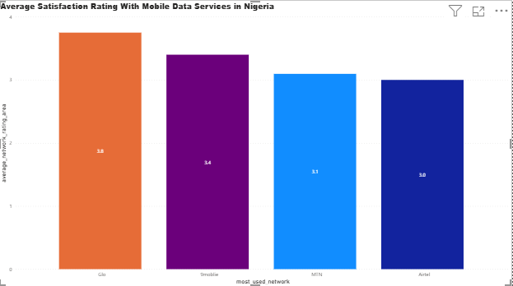
Figure 8: Bar chart showing average satisfaction ratings by network provider.
The network average satisfaction rates, as shown in Figure 8, are as follows: Glo (3.8), 9mobile (3.4), MTN (3.1) and Airtel (3.0). These findings reveal that there are observable variations in the perception of service quality among the key network providers by users. Despite the highest number of users in MTN, users of Glo were more satisfied on average, and this could be explained by the cheaper data plans, better promotions, or more stable quality of the services in some locations. Altogether, the results indicate that user satisfaction is not always linked to network popularity, and it is necessary to consider the role of the quality of services and their value in the development of customer perceptions and loyalty.

Relationship Between Monthly Data Budget and Data Usage
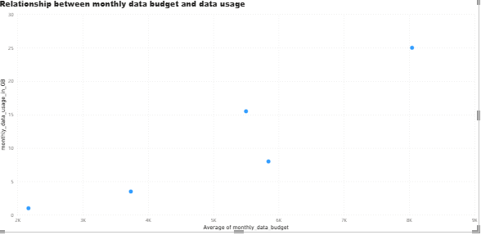
Figure 9: Scatter plot showing relationship between monthly data budget and data usage.
Figure 9 demonstrates that there is a strong association between the monthly data budgets and the level of data usage of the respondents. This implies that those with larger budgets to spend on mobile data every month consume more data as compared to those with smaller ones. The trend implies that the internet consumption behaviour of the users is directly related to their spending power. That is, the higher the affordability of data, the more users are likely to perform data-demanding tasks like video streaming, on-line education, and communication on social media. This result supports the idea that data price is one of the major factors defining usage behaviour, which means that decreasing the price of data or making it more affordable would potentially make Nigerians more active on the internet.

Challenges in Mobile Data Usage
Table 2: Respondents Data Challenges
Data Challenges | Frequency
Poor network speed | 42
Data finishes too fast | 38
High cost | 27
Lack of transparency in data usage | 11
Limited coverage in my area | 3

The challenges that were identified by the respondents regarding the use of mobile data services are presented in Table 2. The most common issue that was reported was the poor network speed (42 responses), which means that many people were not satisfied with the quality and reliability of the network connexions. This was followed by data finishes too fast (38) and high cost (27), which indicates that there has always been an issue of data affordability and transparency in data consumption. Fewer respondents mentioned the absence of transparency in the use of data (11) and limited coverage in their region (3) as the most significant concerns. In general, the results indicate that mobile data are accessible to the majority of users, but the network quality and data affordability are the most challenging areas of user satisfaction and overall digital experience in Nigeria.

Summary of Findings
The research investigated trends in mobile data usage, spending habits and user satisfaction amongst the Nigerians, using 122 valid answers gathered via online survey. The discussion resulted in a number of important findings:
- Network Usage:
MTN became the most popular mobile network to access the internet in Nigeria with Airtel, Glo, and 9mobile coming after it. The domination by MTN is a result of its large coverage and the comparatively superior connexion, particularly in urban regions.
- Mobile Data Usage Patterns:
The most frequent data use purposes were social media (WhatsApp, Instagram, and Facebook), online learning or research, business, and entertainment. This means that mobile data consumption in Nigeria is predominantly driven by social interaction
- Average Monthly Data Spending:
All respondents spent around ₦6,020 on mobile data per month on average. Nevertheless, the average spending of the MTN users was the highest (₦7,105.77), which indicates that users of this network buy more or more expensive data packs.
- User Satisfaction Levels:
Glo had the most satisfaction rating (3.8), then 9mobile (3.4), and then MTN (3.1) and Airtel (3.0). The company with the highest number of users was the MTN, but the Glo customers were more satisfied because they may have cheaper packages. This demonstrates that network popularity is not always related to user satisfaction.
- Relationship Between Data Budget and Usage:
There was a positive correlation between monthly data budgets and actual data usage. Those respondents who used more data spent more on it, which underscores the fact that affordability directly correlates with user engagement and levels of online activity
- Challenges in Mobile Data Usage:
The issues that were highlighted were poor network speed (42 responses), finished data too fast (38), and high cost (27). The reasons given by fewer users included a lack of transparency in data use (11) and limited coverage (3). These findings emphasize that service quality and affordability remain major issues affecting digital accessibility in Nigeria

Conclusion
This research examined trends, consumption habits, satisfaction, and issues related to mobile data usage in Nigeria. The results indicated that mobile data has now become a vital component of daily life, and it has facilitated communication, education, business, and entertainment practises in the nation. Nonetheless, with the extensive use of mobile internet, there are still a number of issues that restrict user satisfaction and the digital inclusiveness.
The analysis revealed that the internet services offered by the MTN are still mostly used by people, but the Glo customers stated that they are more satisfied with the services provided because it is more affordable and valued. Social media was the most common use of mobile data by most of the respondents, although educational and professional purposes were also important. The fact that data budget and consumption showed a positive relationship further indicated that the issue of affordability has a strong impact on the amount of data individuals consume.
Constant issues like poor network speed, high data cost, and fast data drainage are some of the issues that were stated as the problems among the users. These problems indicate that mobile connectivity is on the increase, but the quality and costs of service are the key aspects that require focus.
On the whole, the study conclude that the affordability of data, broader coverage, and improved service quality are the most effective ways to increase user satisfaction and encourage more individuals to engage in the rapidly expanding digital economy in Nigeria.

References
GSMA. (2025, February 3). Mobile internet usage: 60% of Nigerians with 4G coverage don’t use mobile internet. Nairametrics. https://nairametrics.com/2025/02/03/mobile-internet-usage-60-of-nigerians-with-4g-coverage-dont-use-mobile-internet-gsma/
GSMA. (2024). The role of mobile technology in driving the digital economy in Nigeria. GSMA. https://www.gsma.com/about-us/regions/sub-saharan-africa/wp-content/uploads/2024/05/NigeriaDigitalEconomy_R3_Web.pdf GSMA
GSMA. (2024, May 12). GSMA says 71% of Nigerians have no regular access to mobile internet. Nairametrics. https://nairametrics.com/2024/05/12/gsma-says-71-of-nigerians-have-no-regular-access-to-mobile-internet/

